**PH231 Endsemester exam.B – Spring 2021 [60]  
Prerequisite:**You must have a working LTSpice simulation and physical implementation of a waveform **F**unction **G**enerator (FG) that swings to both positive and negative voltages, as used in previous labs.

The official standardized design is published on moodle – use those component values to get a reliable output and test that your FG works as expected.

Add a 100μF (electrolytic) capacitor from VCC to GND for the FG, and for the all other active modules involving BJT’s, both in simulation and the built circuit. As discussed in lecture session, this prevents VCC fluctuations caused by FG BJT’s switching  
Settings for LTSpice: Use the following timing parameters in LTSpice simulation command

Stop time = 101m

Time to start saving data = 100m

Maximum time step = 0.01m

This skips the initial transients in the first 100ms of simulation caused by calculation artefacts, capacitive charging etc and gives you a stable picture of one full cycle of Vin @ *f~ 1kHz*

**Check and reduce dependence of voltage gain of a CE amplifier on load impedance**

**Level 0 10**

**Check how badly the load impedance affects voltage gain of the CE amplifier** (to be done with LTSpice simulation of CE voltage amplifier)

1. What is the output resistance of the high gain CE voltage amplifier as designed and built in Endsem.A (also Lab 4)? **1**  
   Note: at this level we are mostly interested in the ‘resistive’ output impedance.   
   Though there is an output coupling capacitor, all our operational tests are done at a frequency 1 kHz ~ 10× f3dB high-pass cutoff, so for practical purposes that coupling capacitor may be considered a short-circuit  
     
   The output resistance will simply be RC, i.e. 4.7kΩ.
2. So far, we have been probing the output *vout* directly with the DSO probe (red+black crocodile clips) – what is the impedance of this probe? **1**

The impedance is considered to be infinite.

1. If a finite load resistance RL is connected to *vout* do you expect the amplitude of *vout* to be affected? If so, why and how much? **1**  
     
   Yes, the amplitude of vout will change as vout/vin = -(RC||RL)/(re + RE||RE1)
2. Implement a finite RL = 4.7kΩ between *vout* and GND in your simulation to check if your calculation for question 3 is correct. **1**  
   Put photos of your simulation output with a finite RL = 4.7kΩ here:

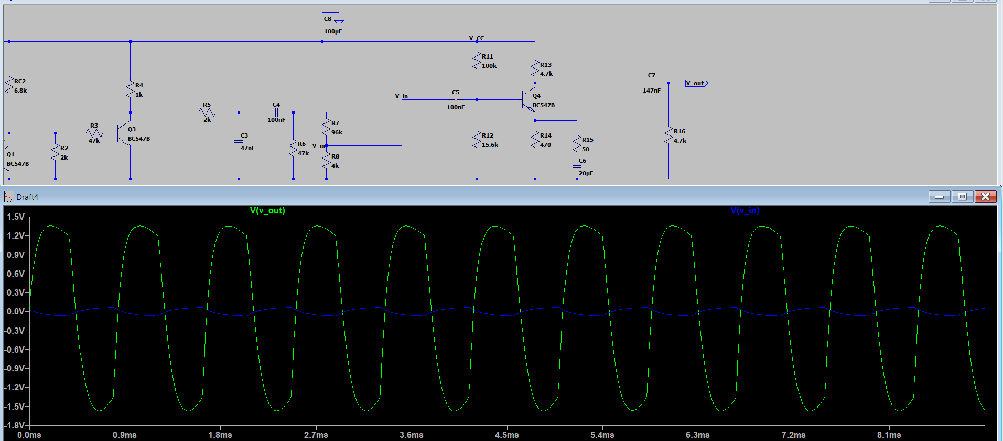

1. **CONCEPT CRACK:** From the above questions 1 – 4, it should be clear that the CE voltage amplifier really doesn’t like to drive small load impedance. We would like to send this *vout =* G×*vin* into a node which always has a high input impedance, so that the amplitude of *vout*is preserved.
   1. What other circuits have you studied in the lab that have (a) high input impedance (b) preserve the voltage amplitude? **1**

Common Collector Amplifier (Emitter follower)

* 1. Can such a circuit (as solved earlier in the semester) be directly plugged in at *vout* of the high gain voltage amplifier? Obviously not. Why not? **1**  
     No, because it will overload the amplifier.
  2. What specific parameters of the desired circuit module must be re-done so that we can use it at *vout* of the high gain voltage amplifier to provide the desired high load impedance? **4**

We add a coupling capacitor so that each transistor is separately biased and blocks the DC operating bias level of one stage from affecting the DC operating point of the next.

Cnew = 1/(2πfRC)

Cnew = 330nF

**Level 1 Fine-tune design of a high-impedance (active) load circuit so that it ‘buffers’ *vout* of the voltage amplifier 15**

Solving questions 1 – **5** of Level 0, you have cracked the idea of the circuit module required to be connected at the output *vout* such that the (high) input impedance of that circuit does not affect the amplitude of *vout* –   
we will call it a ‘buffer circuit’ in this assignment.

We have solved such a buffer circuit design earlier in the semester, though we called it by some other name then. The design parameters & constraints were different. Now that you are a beginner-expert in electronics, go back and re-write the design parameters of that circuit such that it is suitable for use in this context.

1. List the design parameters that are in your control, and features of the design of the earlier used circuit which you now need to re-do to be able use it today as a high input impedance buffer circuit **3**  
      
   We have,

1. VE = 0.5VCC

2. Beta = 300

3. RE = VE/IE

1. Re-design the buffer circuit as per the above design requirements so that it can be applied as a high impedance buffer circuit after the CE voltage amplifier. Give all your calculation steps here: **6**  
   Taking ICQ = 10mA, we design an emitter follower as done in Lab 3

Since IE ~ IC, IE = 10mA. Therefore, RE = 470Ω.

Now, RB = 𝛽(𝑟𝑒+𝑅𝐸) = 148.5kΩ.

We now choose RB1 and RB2 such that RB1 || RB2 << RB. Hence. 22kΩ and 47kΩ

satisfy the given condition.

1. Put your LTSpice simulation circuit diagram and results for the buffer circuit here. **6**  
   For this question just include the cracked and designed buffer circuit, driven by the FG (don’t include the CE voltage amplifier of Endsem.A)   
   Label the nodes sensibly where you are measuring *I, V*   
   Result plots expected:
   1. *vin v/s iin*  (shows Rinp of your buffer, hope it is constant and high!) Measure the slope and record your simulated Rinp­­ – does it match the value calculated for Question 2 above?
   2. *vout*(t) and *v*in(t) → to be compared with experiment.

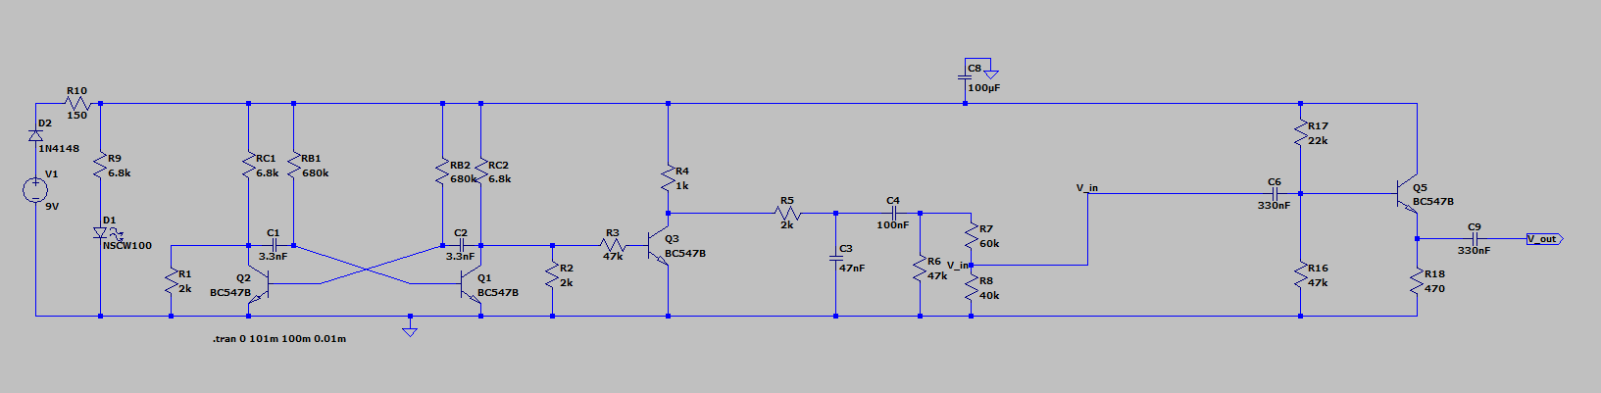

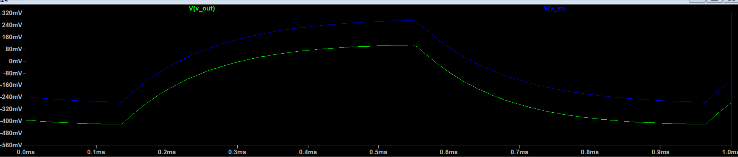

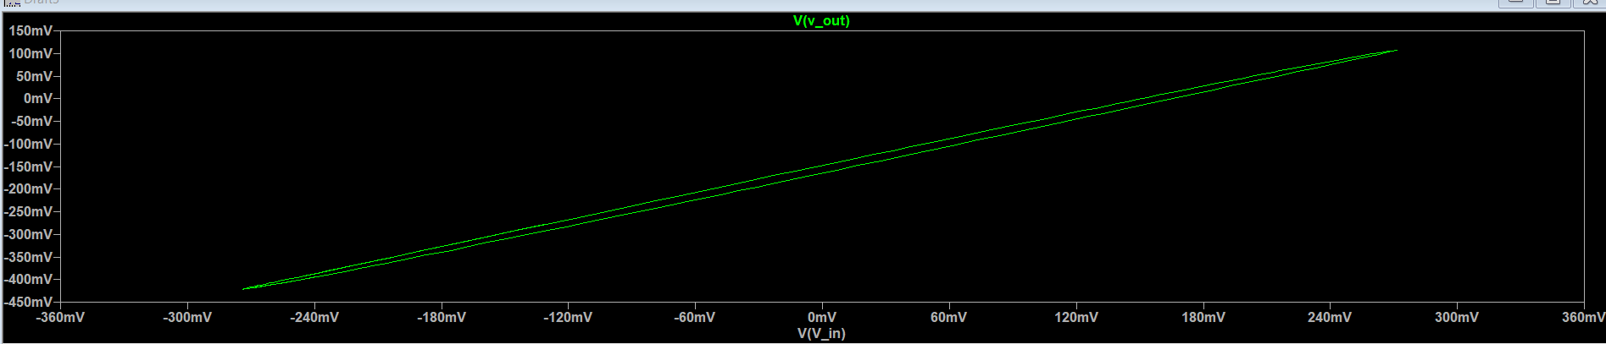

**Level 2 Buffer circuit demo and grand end-to-end assembly demo**

**Level 2.A buffer circuit demo 20**

Build your high input impedance buffer circuit as designed at Level 1 on your breadboard. Provide it with input from your FG. Set the output RL = 4.7kΩ   
Omit the intermediate high gain CE voltage amplifier (Endsem.A) at this stage to simplify debugging.  
 Set amplitude of FG output to a value you would expect to get from your high gain CE voltage amplifier.  
Put photos of your circuit assembly and measurements (with DSO + ID) here. Label the photos indicating which trace is *vin* and *vout*  to this buffer circuit

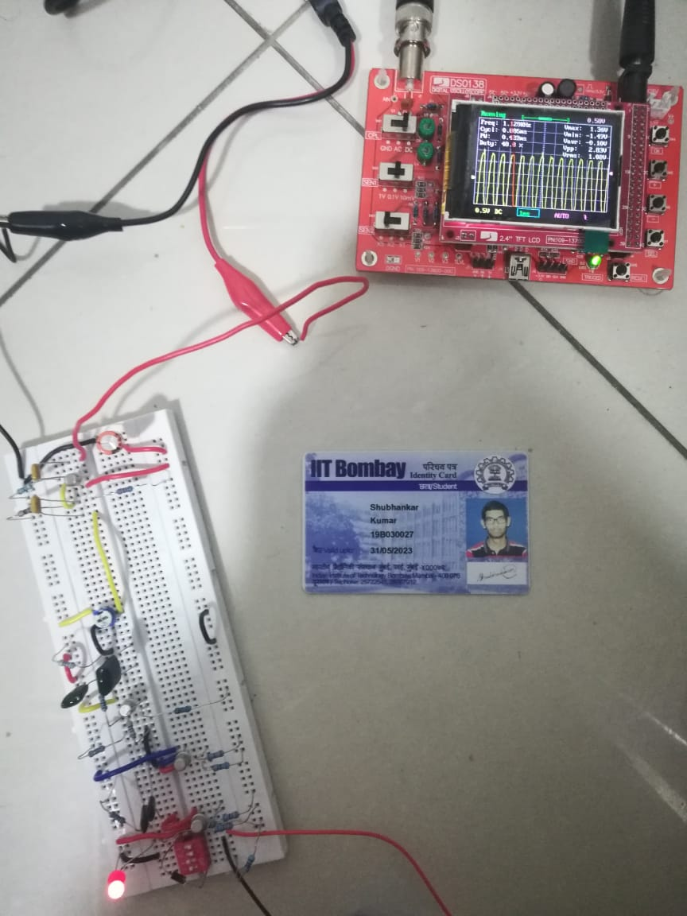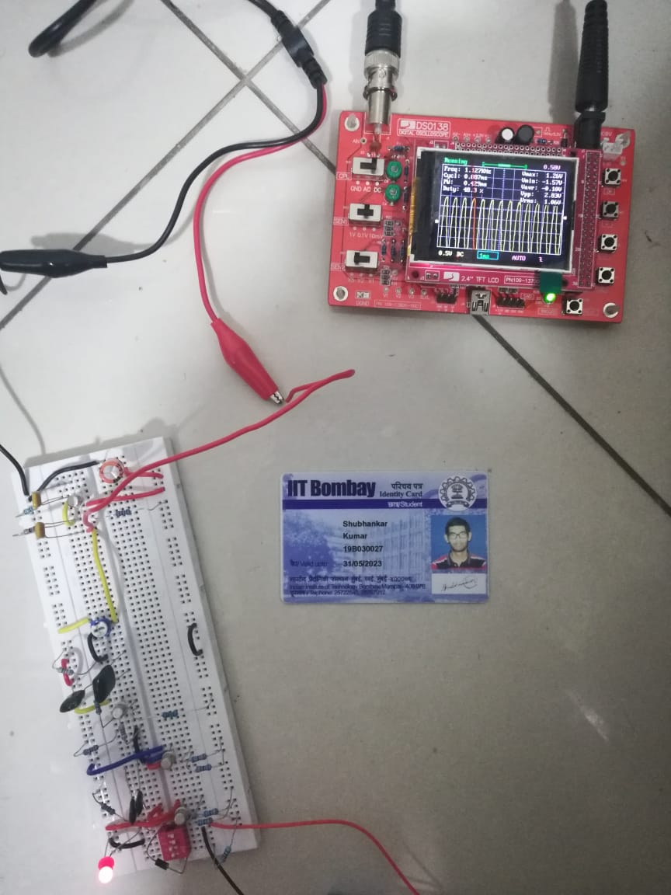

VIN VOUT

**From the two images, we see that the vout/vin ~ 1, i.e. voltage gain for the emitter follower is nearly constant, which is as expected.**

**Level 2.B end-to-end test 15**

Do an end-to-end test of circuits from Endsem.A and Endsem.B together with a final load   
**RL = 4.7kΩ**

Demonstrate linear behavior of the following chain:  
 FG

∟high gain voltage amplifier (Endsem.A)

∟ buffer circuit (Endsem.B)

∟**RL=4.7kΩ**

Put labelled photos below of the voltage as measured at each stage of the above chain.

Fallback option for those running out of time and ideas:  
If: you were unable to solve Endsem.A problem,

Then: you can replace that stage with the pre-designed circuit from Fig 1 of Endsem.A (i.e. CE voltage amplifier with voltage gain G=–10 like Lab 4).

Then: Test your solution to Endsem.B   
i.e. it is acceptable to demonstrate for reduced marks, to demonstrate the following:

FG → CE voltage amplifier (G = – 10) → driving Endsem.B buffer → final load RL = 4.7kΩ maintaining net voltage G ~ –10

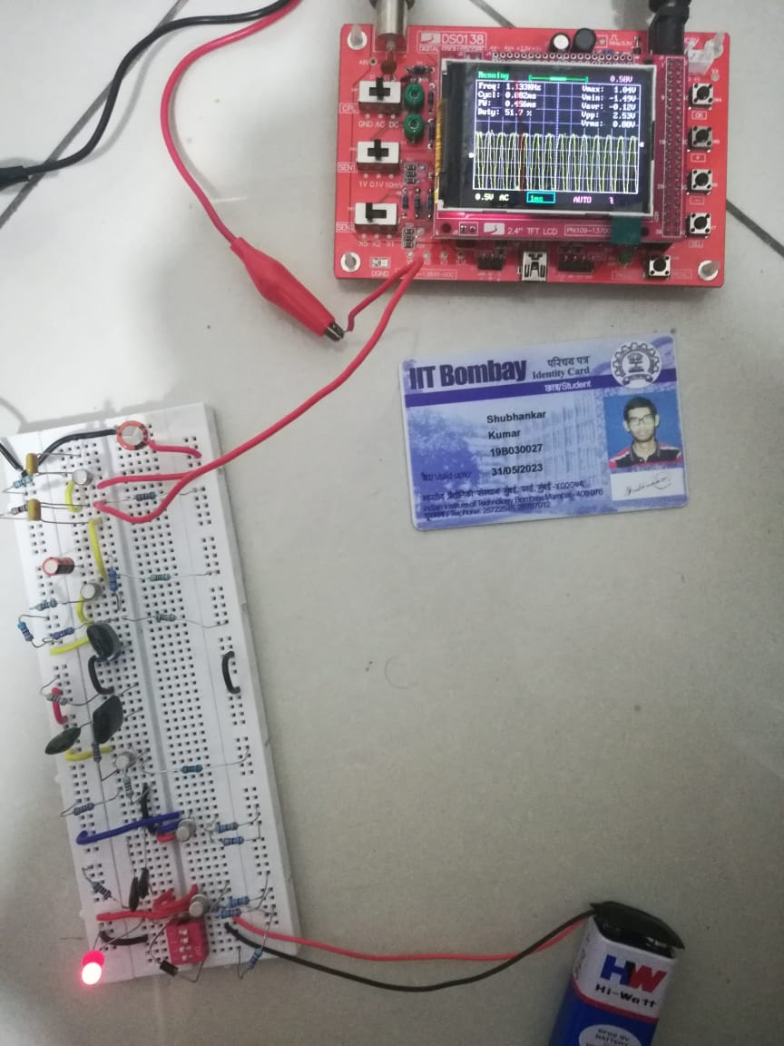

High gain Voltage Amplifier

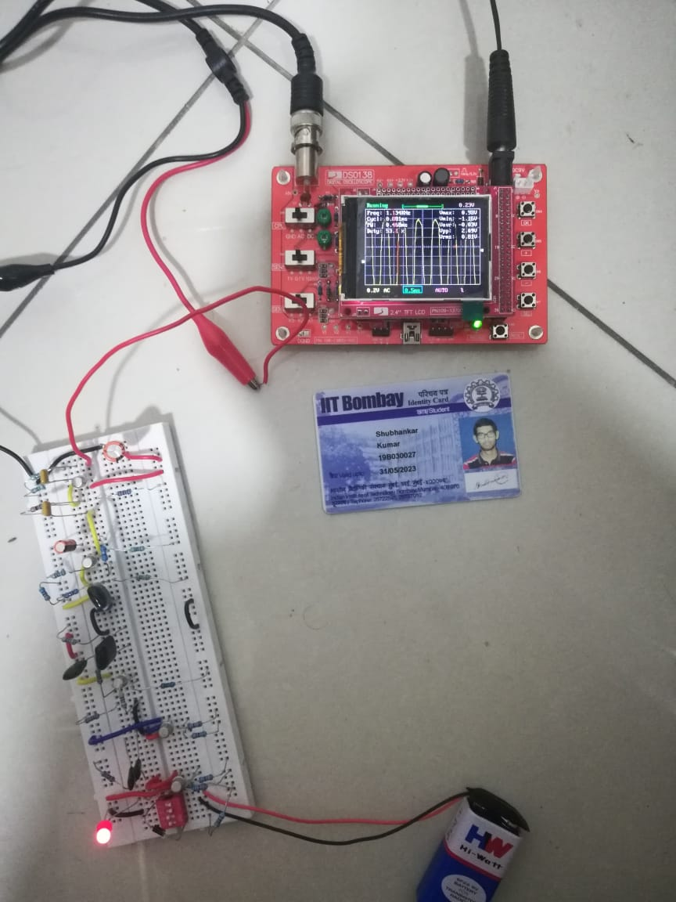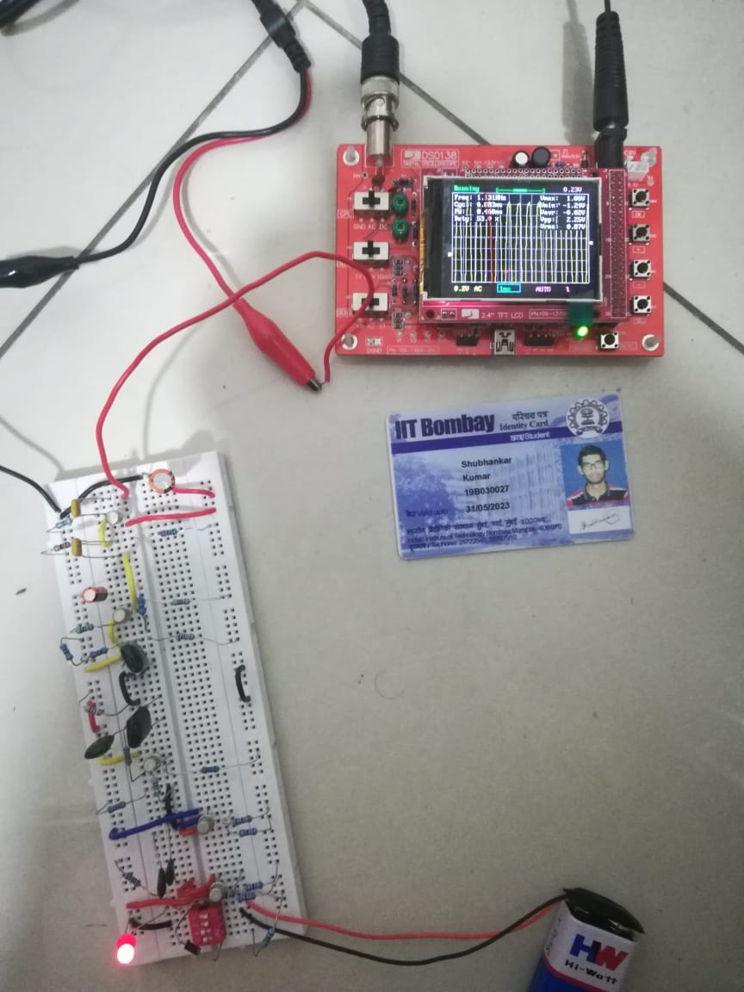

High gain voltage amplifier with High gain voltage amplifier +

Buffer circuit (Emitter follower) Buffer circuit + Load resistance

--------------end of exam---------------